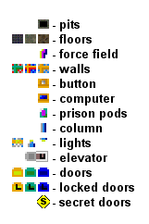

BackTrack™

Hints

Level 1
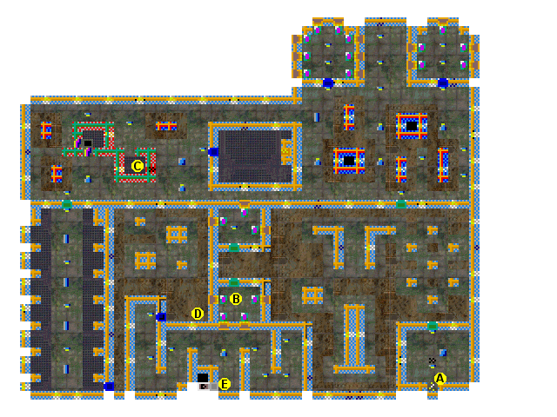
A – This is where you start. Do not enter the teleport until you have started the self-destruct sequence at the end of the game.

B – You will find many Prison Pods with humans that you must rescue. Each time you rescue a character, a countdown will appear to inform you how many more prisoners you need to free to finish the game.

C – You will find a chain gun here.

D – A cyborg carries a keycard that you need to progress passed the locked door.

E – Elevators whisk you level to level within the moon base.
Level 2
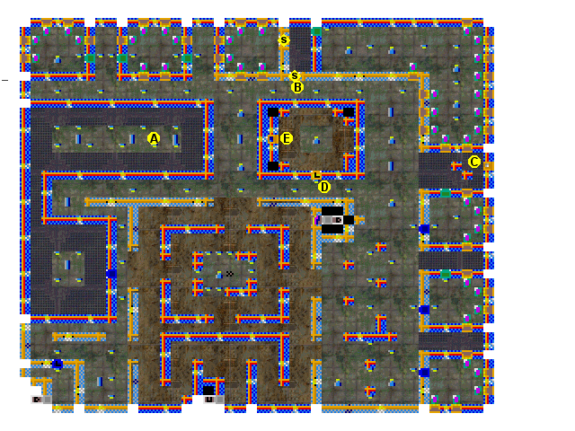

A – You can find a laser weapon here, along with batteries and armor.

B – Past the oil drums is a secret door. Shoot the drums, then open the secret door.

C – There is a dying soldier that talks about a switch to unlock the control room, here is the switch you need to flip.

D – This door only unlocks when you flip the switch at C.

E – This is a computer terminal. You need to unlock the doors with it. You also must disable the failsafes on all the computer terminals to activate the self destruct sequence at the end of the game. When you unlock the door or drop the force field, you will be able to leave this level.
Level 3
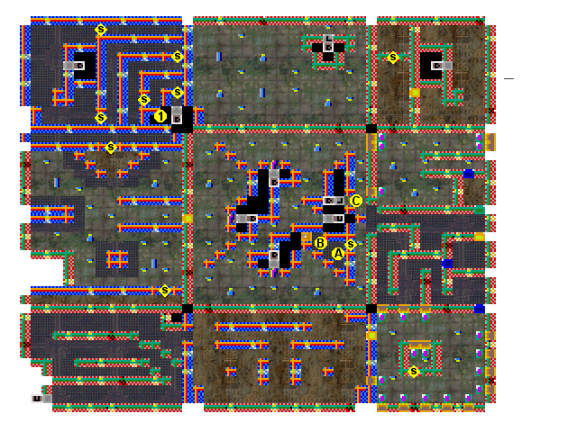
A – Behind the secret door is a dying solder that will trade you 3 keycards for a keycard that will open up the door to the next level.

B – This button toggles an open force field at three locations. Each time you press the button a different force field will turn off and the old one will turn on. Behind each force field is an elevator that will take you to another keycard.

C – This door will unlock with dying soldier’s keycard.

1 – You can enter this area from a couple of levels down. Behind all the secret doors is an elevator to a secret level.

Level 4
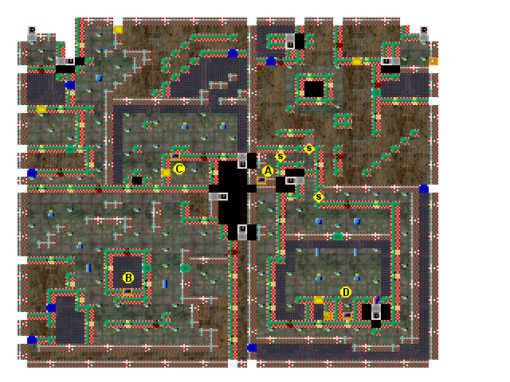

A, B, & C – There is a cyborg in each of these areas. This is a cyborg boss, and is much stronger that the other varieties of cyborgs, approach with caution. Once you defeat each boss, it will drop a keycard. Get all three keycards to have the dying soldier construct a new one for you.

D – You need to get to the computer to drop the force field to get to the next level. There are several cyborgs that will attempt to stop you. The door into this arena will lock once you enter it, and you cannot unlock it until the boss is defeated. Enter with caution!

